**ODIN II**

**System Design: Functional Decomposition**

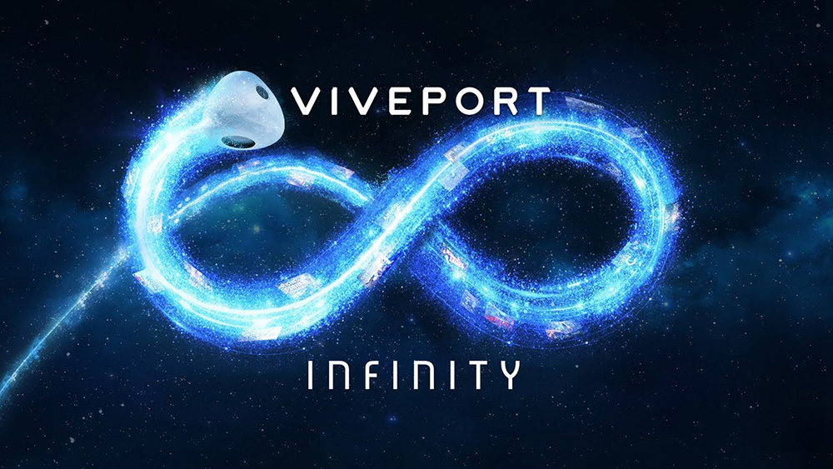

TEAM 11

TODD TOWNSEND, ABRAM FOUTS, KARLA BARRAZA LOPEZ, WENHAO CHENG, XUENING JIA

Sponsor: Brad Smith - Intel Corporation

Advisor: Fu Li

